Apples to Apples: An Analysis of Geographic Influence in Federal Sentencing
Douglas C. Sauncy
Western Governors University

Table of Contents
A. Project Highlights 3
B. Project Execution 3
C. Data Collection Process 5
C.1 Advantages and Limitations of Data Set 6
D. Data Extraction and Preparation 6
E. Data Analysis Process 7
E.1 Data Analysis Methods 7
E.2 Advantages and Limitations of Tools and Techniques 8
E.3 Application of Analytical Methods 9
F Data Analysis Results 10
F.1 Statistical Significance 10
F.2 Practical Significance 13
F.3 Overall Success 14
G. Conclusion 14
G.1 Summary of Conclusions 14
G.3 Recommended Courses of Action 18
H Panopto Presentation 19
References 20

A. Project Highlights
This analysis was conducted to answer the research question: When analyzing federal criminal sentencing outcomes across the United States, does geographic location indicate a statistically significant influence on sentence length after controlling for relevant legal factors such as offense type, offense severity, and criminal history?
The scope of this project’s analysis was limited to federal sentencing data downloaded from the United States Sentencing Commission for the fiscal year 2024, encompassing individual (as opposed to organization) cases sentenced between October 1, 2023, and September 30, 2024, with its focus on specific key variables related to sentencing-influencing factors.
This project followed the CRISP-DM (Cross-Industry Standard Process for Data Mining) methodology, an iterative six-phase framework that provides a structured and systematic approach to data analysis. Its clearly defined phases (business understanding, data understanding, data preparation, modeling, evaluation, and deployment) aligned closely with the progression of this project.
The tools utilized for this project included Python for data extraction, cleaning, analysis, and visualizations and a Jupyter Notebook environment, which provided output and visualizations along with the code.

B. Project Execution
The project followed the path outlined in the Task 2 document successfully and without variance. The primary goal of this analysis was to answer the research question using a multiple linear regression model that would run without error and produce accurate, acceptable results, which it did.
This analysis used the CRISP-DM methodology to guide the progression of the project, with each phase (business understanding, data understanding, data preparation, modeling, evaluation, and finally deployment) transitioning naturally from one to the next.
The timeline proposed in Task 2 was followed closely with little to no deviation. Each deliverable was achieved without any notable issues or obstacles that delayed the progress of this analysis. The anticipated duration of each task was sufficient for completing each task and achieving each milestone.
Milestone or deliverable | Duration  (hours or days) | Satisfied time expectations?
Deliverable 1.0.1: Documentation of research question and hypothesis | 4 hours | Yes
Deliverable 1.0.2: Definition of project scope, goals, and success criteria | 4 hours | Yes
Deliverable 1.1.1: Download USSC Individual datafile FY 2024 | 1 hour | Yes
Deliverable 1.1.2: Clean and prepare dataset with relevant variables | 10 hours | Yes
Deliverable 1.2.1: Descriptive statistics for sentence length distributions | 10 hours | Yes
Deliverable 1.2.2: Visualizations of geographic variation in sentencing | 8 hours | Yes
Deliverable 1.2.3: Correlation analysis of sentence length and legal factors | 8 hours | Yes
Deliverable 1.3.1: Multiple linear regression model development | 8 hours | Yes
Deliverable 1.3.2: Hypothesis test results (F-tests and t-tests) | 8 hours | Yes
Deliverable 1.3.3: Identification of districts with significant deviations | 8 hours | Yes
Deliverable 1.4.1: Jupyter Notebook with complete analysis | 8 hours | Yes
Deliverable 1.4.2: Final report with findings and recommendations | 8 hours | Yes
Milestone: Project complete | 80 hours | Yes

C. Data Collection Process
The anticipated means of locating and acquiring the data did not differ from the actual execution of the plan. The datafile was regularly maintained by the United States Sentencing Commission and made available specifically for the purposes of analysis, so there was a reasonable expectation that it would not be overly difficult to collect or process, and as it was publicly available anonymized data, the main concern regarding governance and security was to ensure it was held on a sufficiently protected device, which it was. No unplanned governance issues were encountered during the project.
The primary concern encountered was how the “life sentence” and “time-served” (470 and 0.03 months, respectively) values were coded. The accompanying codebook (https://www.ussc.gov/sites/default/files/pdf/research-and-publications/datafiles/USSC_Public_Release_Codebook_FY99_FY24.pdf) confirmed these as valid coded values. The log transformation applied to the column handled the skew they contributed to.

C.1 Advantages and Limitations of Data Set
The biggest advantage to using this dataset is that it contains a massive amount of anonymized data (61,678 rows and 27,265 columns), all of which is regularly maintained by a reliable source (the United States Sentencing Commission) and made readily available to the public in a format specifically prepared for analytical purposes. Its accompanying codebook, also made freely available by the USSC, helped navigate the otherwise insurmountable task of identifying the necessary variables out of the tens of thousands there are.
One limitation of this dataset is that while it contains extensive quantitative data about sentencing outcomes, it provides no qualitative explanation for why a judge might deviate from the national average or sentence outside the range suggested by federal guidelines. For example: the analysis identified the Western Louisiana district as sentencing nearly 80% above the national average, but the data alone cannot explain whether that reflects judicial philosophy, local prosecutorial patterns, or other factors outside the scope of this analysis.

D. Data Extraction and Preparation
The source of data for this project was the United States Sentencing Commission Individual datafile for the Fiscal Year 2024 (https://www.ussc.gov/research/datafiles/commission-datafiles#individual). It was downloaded as a .csv file (https://www.ussc.gov/sites/default/files/zip/opafy24nid_csv.zip), along with an accompanying codebook in .pdf format (https://www.ussc.gov/sites/default/files/pdf/research-and-publications/datafiles/USSC_Public_Release_Codebook_FY99_FY24.pdf).
Within a Jupyter Notebook environment, the data was loaded into a pandas dataframe. Using the codebook to identify the relevant variables, a new dataframe was created containing only six columns – sentence length (SENTTOT), district (CIRCDIST), offense type (OFFGUIDE), offense level (XFOLSOR), criminal history category (XCRHISSR), and circuit (MONCIRC) – and then further cleaning was performed to remove rows with missing values. Ultimately a dataframe of 55,759 clean and complete rows was produced.
Because the distribution of sentence lengths was somewhat offset by the large number of coded sentence values at 0.03 months (time-served) and 470 months (life), a log transformation was applied to the SENTTOT column prior to modeling.

E. Data Analysis Process

E.1 Data Analysis Methods
An OLS (Ordinary Least Squares) multiple linear regression model was developed to quantify the relationship between sentence length and the independent variables (offense type, offense level, criminal history, and district.) This method was appropriate because it allowed for the simultaneous examination of multiple variables while isolating the effects of each one, which was necessary when controlling for legal factors in order to measure the independent influence of geography.
An overall F-test was performed to determine whether or not the regression model as a whole would explain the variation in sentence lengths. This was a necessary first step to confirm the model was valid and worth further interpretation before examining the contribution of individual variables.
A restricted F-test was then performed. The restricted F-test was an appropriate method for isolating the specific contribution of geographic location to sentencing outcomes. Unlike the overall F-test, it directly tested whether or not district variables explained variance beyond what legal factors alone account for, which is precisely what the research question requires.
Finally, individual t-tests were conducted on each district coefficient produced by the regression model. While the restricted F-test established whether or not geography matters as a group, the t-tests identified which specific districts were most responsible for that influence and quantified their deviation from the national mean.

E.2 Advantages and Limitations of Tools and Techniques
The primary tools used for this analysis were Python, thanks to the robustness of its libraries such as pandas and statsmodels, and the Jupyter Notebook environment wherein the code was executed. Python as the base upon which the analysis was written was foundational in tackling this analysis as its ease of use and access to robust packages such as the pandas and statsmodels libraries which were relied on to perform the analysis.
One limitation of Python is that working with a dataset as large as the one used in this project had the potential to be computationally slow, though the use of the codebook to isolate only the necessary columns significantly reduced the size of the working dataframe and mitigated this concern.

E.3 Application of Analytical Methods
- Environment Setup, Data Loading, Preliminary Data Exploration
  - Imported libraries (pandas, numpy, statsmodels, matplotlib, seaborn)
  - Loaded raw CSV into a pandas dataframe
  - Explored the data
- Data Preparation and Cleaning
  - Located the six relevant columns needed using the codebook
  - Dropped rows with missing values (from 61,678 to 55,759)
  - Verified variable ranges against codebook (offense level 1–43, criminal history 1–6)
  - Converted categorical columns to strings
- Exploratory Data Analysis
  - Examined coded edge values (0.03 for time-served and 470 for life) and confirmed them as valid per the codebook
  - Generated charts to better visualize the data; a histogram of raw sentence lengths (where a heavy right skew was observed), bar chart of mean sentence by district, a scatter plot of sentence length vs. offense level, a box plot of sentence length by criminal history category, and a bar chart of mean sentence by offense type
  - Ran Pearson correlation analysis on offense level, criminal history, and offense type against sentence length to confirm their relationships prior to modeling
- Statistical Modeling
  - Log-transformed the column SENTTOT to address right skew caused mostly by time-served values observed in step 3.2
  - Built the full OLS model using sum coding on the district variable, which centers each district's coefficient around the national mean
  - Built a restricted OLS model excluding the district variable, to serve as a baseline for comparison
- Hypothesis Testing
  - Ran an overall F-test on the full model to confirm its validity
  - Ran restricted F-test comparing the full and restricted models to isolate the contribution of geography
  - Extracted district coefficients and ran individual t-tests to identify which specific districts deviated significantly from the national mean
- Model Diagnosis
  - Generated residuals vs. fitted plot to check for linearity and homoscedasticity
  - Generated a Q-Q plot to check for normality of residuals
  - Generated a histogram of residuals to further verify normality and to observe that OLS assumptions were confirmed as sufficiently met

F Data Analysis Results

F.1 Statistical Significance
1. Overall Model F-Test
- Null Hypothesis: None of the independent variables (district, offense type, offense level, criminal history) explain variation in sentence length.
- Statistical Test: An overall F-test was conducted using an OLS (Ordinary Least Squares) regression model.
- Metric: The F-test produced an F-statistic of 416.98 and corresponding p-value of less than 0.001, indicating the model explains a statistically significant portion of variance in sentence length.
- Alpha: α = 0.05, P-value: < 0.001.
- Conclusion: The p-value in this test being less than α indicates sufficient evidence to reject the null hypothesis and support the claim that the independent variables collectively explain a statistically significant portion of the variation in federal sentence length.
2. Restricted Model F-Test
- Null Hypothesis: Geographic location has no statistically significant influence on sentence length after controlling for offense type, offense severity, and criminal history.
- Statistical Test: An F-test was conducted comparing the full model (including district variables) against a restricted model containing only legal control variables.
- Metric: The test produced an F-statistic of 40.2985 and p-value of less than 0.001, indicating the addition of district variables explains a statistically significant amount of variance beyond what legal factors alone account for. The R² values of both models were compared to quantify the contribution of geographic location.
- Alpha: α = 0.05, P-value: < 0.001.
- Conclusion: There is sufficient statistical evidence to reject the null hypothesis; geographic location does have a statistically significant influence on federal sentence length after controlling for offense type, offense severity, and criminal history.
3. Individual District T-Tests
- Null Hypothesis: An individual district's sentencing outcomes do not deviate significantly from the national average after controlling for offense type, offense severity, and criminal history.
- Statistical Test: T-tests were conducted on each district coefficient produced by the regression model.
- Metric: Each district produced a t-statistic and a corresponding p-value indicating whether or not that district's sentencing outcomes deviate significantly from the national average.
- Alpha: α = 0.05.
- Conclusion: Of the 94 districts included in the analysis, 70 produced a p-value of less than alpha, thus providing sufficient evidence to reject the null hypothesis for at least for 70 districts deviating significantly from the national mean.
4. OLS Regression Model
- Type: Supervised regression model.
- Algorithm: Ordinary Least Squares (OLS) multiple linear regression, implemented in Python using the statsmodels library. The dependent variable (sentence length) was log-transformed to address skewed distribution. Sum coding was applied to categorical variables so that district and offense type coefficients reflect deviations from the national average rather than an arbitrary baseline.
- Performance Metric: R² (coefficient of determination) ≥ 0.40, measuring the proportion of variance in sentence length explained by the model.
- Conclusion: The model produced an R² of 0.48, indicating that the independent variables collectively explain 48% of the variance in federal sentence length. This supports the hypothesis that geographic location has a statistically significant influence on sentencing outcomes.

F.2 Practical Significance
Crimes charged at a county or state level are prosecuted under jurisdiction-specific policies and are often influenced by the local context in which they occurred. It is reasonable, then, that sentencing outcomes at that level would have some degree of geographic variation. But crimes charged at a federal level are subject to sentencing guidelines and policies that are intended to treat anywhere in the United States as anywhere else in the United States – a uniform system with no geographic consideration. One would then expect a consistency with regards to sentencing outcomes of similarly situated defendants, after controlling for all relevant legal factors.
This analysis was conducted to determine how consistent that uniformity is. A district-level deviation of 20% or more from the national average was used as the benchmark to determine meaningful disparity, a benchmark that was exceeded by a substantial number of districts. The most extreme examples were Nebraska (which sentenced nearly 85% below the national average), and Western Louisiana (which sentenced nearly 80% above it.) For otherwise identical cases, the difference between being sentenced in those two districts could be the difference between a few months and several years.
The significance of these findings carry real practical weight. The United States Sentencing Commission could take the district coefficient output produced by this analysis and immediately identify which districts need review with no additional analysis required. The bar charts and choropleth map translate those coefficients into easily understandable visuals.

F.3 Overall Success
The project was a success, achieving every goal and measure established within the planning phase. The success criteria were for the model to run correctly and without error, achieving an R² of at least 0.40, and produce clear and interpretable hypothesis results supported by accurate visualizations.
The OLS multiple linear regression model ran without error and produced an R² of 0.48, exceeding the established benchmark by 0.08. The visualizations produced throughout the analysis communicated the findings from start to finish, from the distribution of raw data to the geographic patterns revealed by the regression model. The project answered the research question clearly and produced district-level insights that can be used for federal sentencing policy and oversight.

G. Conclusion

G.1 Summary of Conclusions
The primary goal of this analysis was to determine whether or not geographic location has a statistically significant influence on federal sentencing outcomes. The analysis proved that after controlling for relevant legal variables (offense type, offense severity, and criminal history), geography matters quite a lot.
An OLS multiple linear regression model produced an R² of 0.48, indicating that the independent variables collectively explain 48% of the variance in federal sentence length, exceeding the benchmark of 0.40 and confirming the model's validity.
A restricted F-test confirmed that district variables collectively contribute significant explanatory power beyond legal factors alone. 70 of 94 districts deviated significantly from the national average, with the most extreme examples being Nebraska (which sentences nearly 85% below the national average) and Western Louisiana (which sentences close to 80% above it).
These findings illustrate that for otherwise identical cases in the federal justice system, the crime they committed can be as consequential as where they happen to be sentenced.

G.2 Effective Storytelling
The visualizations utilized in this analysis were produced in a Jupyter Notebook environment using Python and taking advantage of its matplotlib, seaborn, and plotly libraries. The visualizations, along with the code and accompanying notes and markdown cells were designed to guide the reader through the findings from start to finish.
Two histograms of sentence length distribution illustrate the right-skewed nature of the data and the effect of the log transformation:
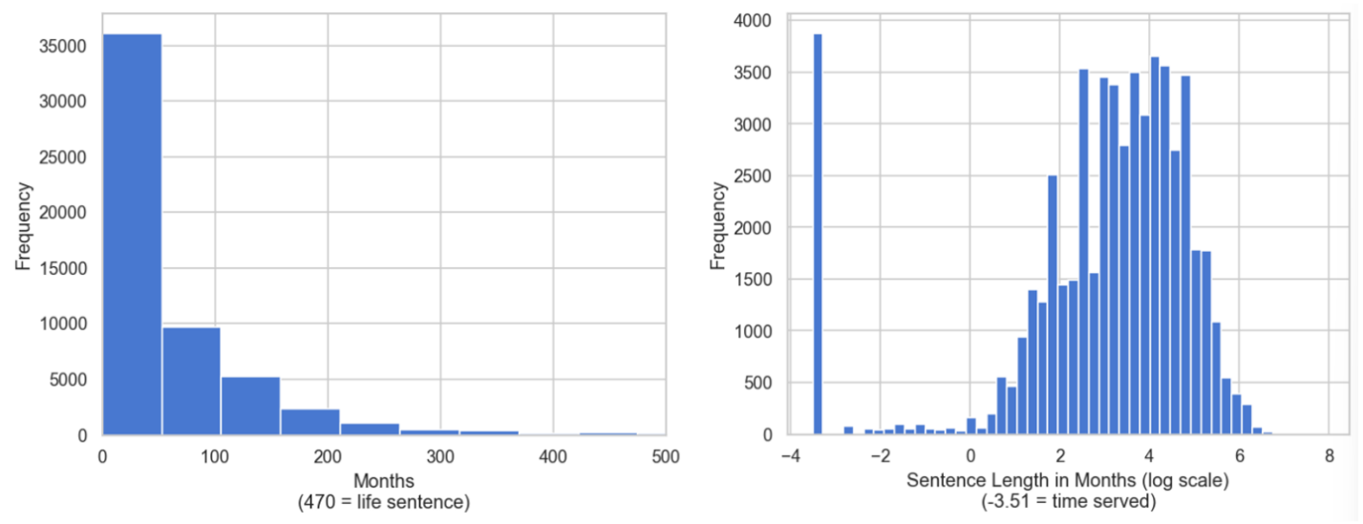
Figure 1: Distribution of federal sentence lengths in months (left) and log-transformed sentence lengths (right)
A scatter plot of sentence length versus offense level and a box plot of sentence length by criminal history category visually confirmed the relationships between legal factors and sentencing outcomes, providing context for the multiple linear regression model.
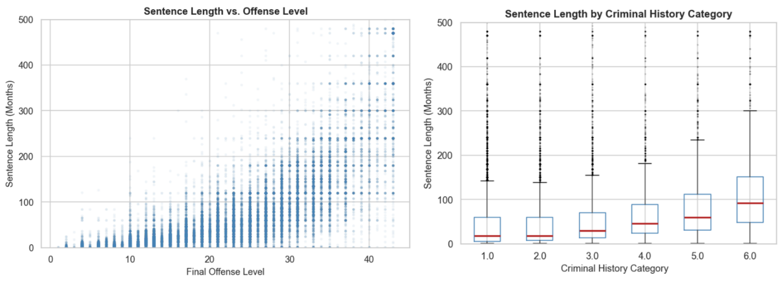
Figure 2: Scatter plot comparing sentence length to offense level (left) and box plot comparing sentence length to coded criminal history category (right)
A district coefficient bar chart ranked the top 20 and bottom 20 districts by their deviation from the national average, with red bars indicating districts sentencing above the mean and blue bars indicating those below, making immediately visible the disparities contained therein.
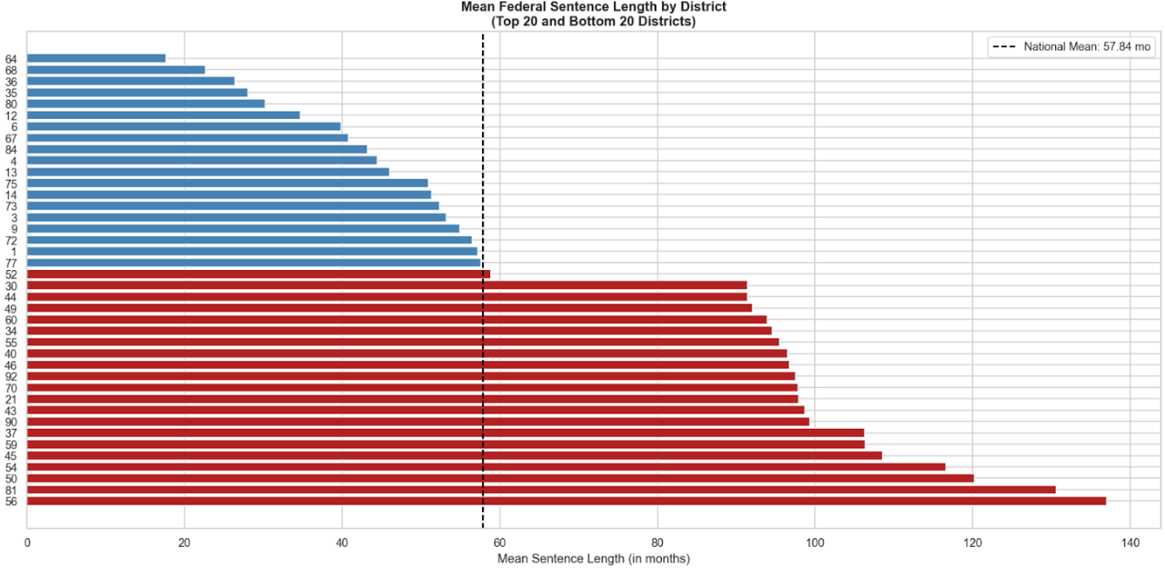
Figure 3: Bar chart of mean sentence length of top and bottom 20 districts
A choropleth map illustrates these findings onto a geographic canvas, allowing viewers to identify regional sentencing patterns at a glance.
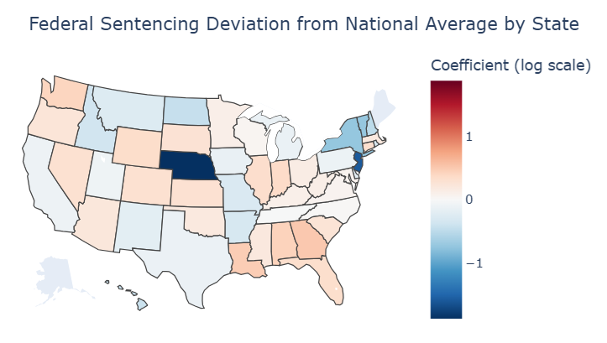
Figure 4: A choropleth with color coded deviation from the national mean
Finally, residual diagnostic plots, including a residuals versus fitted values plot, a Q-Q plot, and a residual distribution histogram, were used to validate assumptions of the multiple linear regression model.
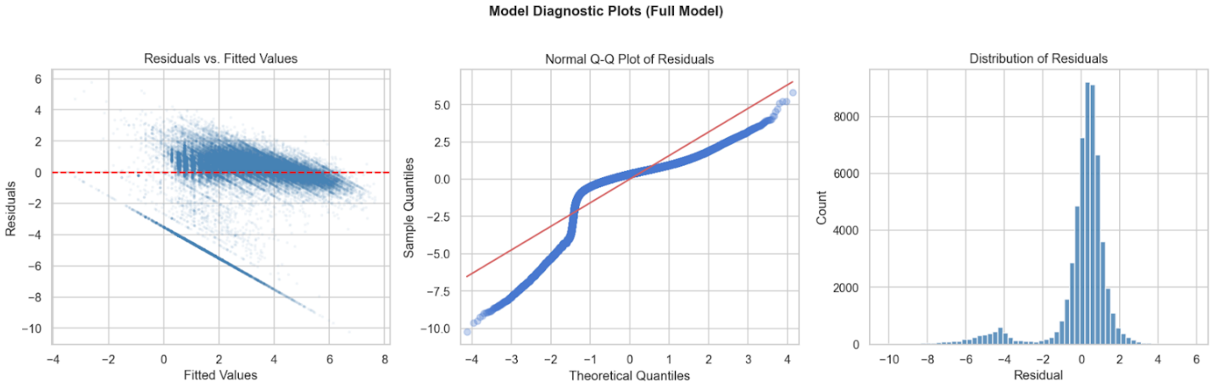
Figure 5: Residuals versus fitted values (left), normal Q-Q plot (center), and distribution of residuals (right)

G.3 Recommended Courses of Action
The research question addressed a concern that the judicial system designed to treat federal sentences uniformly may not be uniform, and the analysis showed that for 70 of the 94 districts sampled there was a very strong indication of deviation from the national mean.
Two logical courses of action come to mind. First, the United States Sentencing Commission can use the district-level coefficient data produced by this analysis to target districts with the most significant deviations from the national average for training, education, compliance and calibration so as to better meet the expectations of federal sentencing guidelines. Districts like Western Louisiana, for example, which sentenced nearly 80% above the national average for otherwise identical cases, represent a meaningful departure from the national mean.
Second, the United States Sentencing Commission could examine whether or not the federal sentencing guidelines themselves should be revised in areas where significant geographic deviation is observed. If districts are consistently sentencing outside the recommended ranges, it may be indicative that the guidelines are too vague or too open to subjective interpretation in certain offense categories. Revising those guidelines to reduce interpretive flexibility could narrow the gap between intended and actual sentencing uniformity.

H Panopto Presentation
https://wgu.hosted.panopto.com/Panopto/Pages/Viewer.aspx?id=fbfaffcb-afe4-4814-9f81-b40e005d5240

References
Miller, J. M. (2025). Sentencing disparities in the United States. International Journal of Social Science Research and Review, 8(5), 35–48. https://doi.org/10.47814/ijssrr.v8i5.2635

An overview of the federal sentencing guidelines. (n.d.). United States Sentencing Commission. https://www.ussc.gov/sites/default/files/pdf/about/overview/Overview_Federal_Sentencing_Guidelines.pdf

United States v. Booker, 543 U.S. 220 (2005). https://supreme.justia.com/cases/federal/us/543/220/

